***[Genesis Auto Mobile Store and Service](http://1000projects.org/genesis-auto-mobile-store-service-java-project.html)***

We designed the Auto Mobile Store and Service project where we added new module in which we need to show the graph of cars brands that got problems in the past 10 years,

For example: If the user selects car brand Toyota the graph should show the total number of cars that got problems in past year and the other graph should show the graph of what kind of problems that particular car had to face like engine problems, tire flat problem and another kind of problems. If you can do this we can clarify further on this and give you the respective data for this module. It is actually data visualization functionality which should show graphs based on data we give.

**Video Changes :**

Make below changes and send a new video with all new changes in video

Auto Mobile Store and Service Project explanation (All the functionalities in the application)  
Change “AMSM” to “Genesis” in all pages of application and make every page look appealing like real-time automobile sites  
the pages in the video are outdated and header images sidebar images are not even half the length of the page.

Create different login For Admin and Customer and pls how can we do that in a database like creating user ids and giving permissions.

In the Available Brands scrolling section in the login page, we need images of American car logos like Audi, BMW, Dodge, etc.If u want we can provide you with the logos and brand names

Please use the following as usernames for logging in and any password

Admin Login Username1: Anurag  
Admin Login Username2: Rajesh

[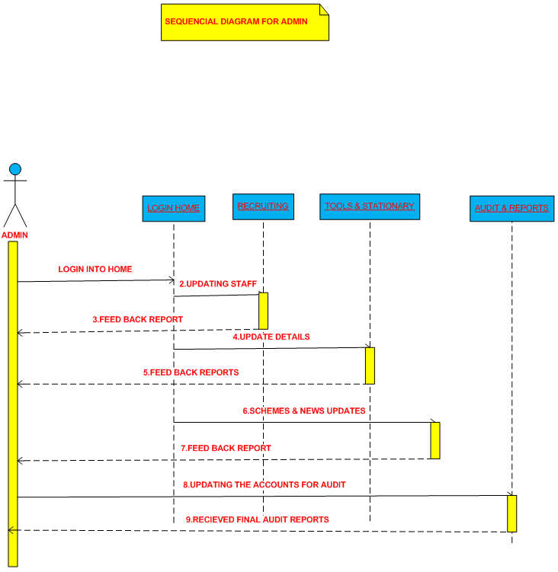](http://1000projects.org/wp-content/uploads/2017/12/Genesis-Auto-Mobile-Store-and-Service-Java-Project-Sequence-Diagram-for-Admin.png)[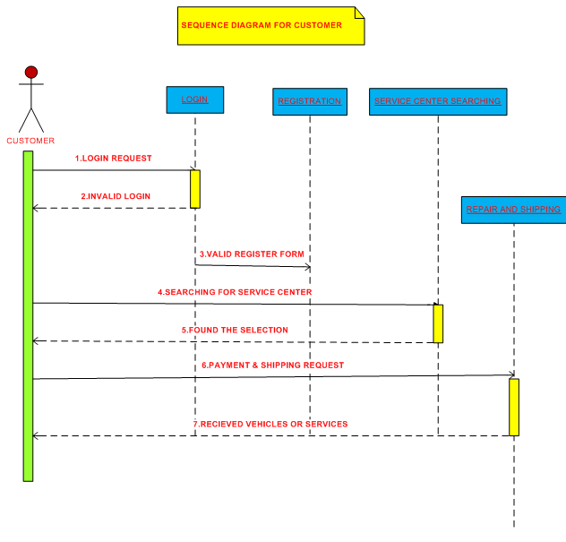](http://1000projects.org/wp-content/uploads/2017/12/Genesis-Auto-Mobile-Store-and-Service-Java-Project-Sequence-Diagram.png)[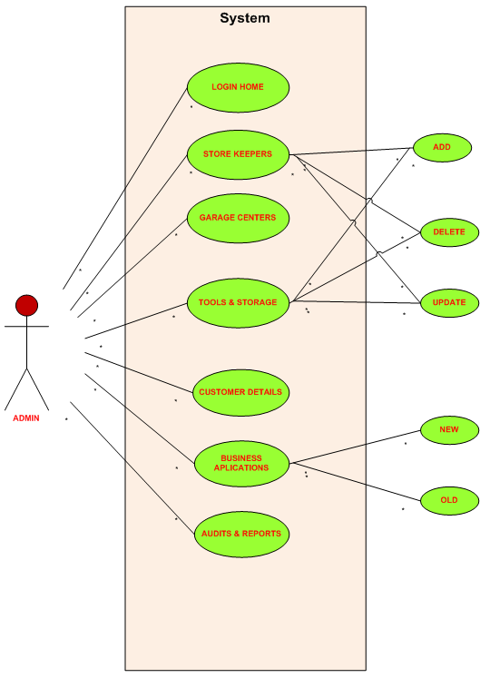](http://1000projects.org/wp-content/uploads/2017/12/Genesis-Auto-Mobile-Store-and-Service-Use-Case-Diagram-for-Admin.png)

Available products page and inventory page use only US related product names and price in dollars.Make navigation bars effective and attractive throughout the application

Please explain the difference between Products page and inventory page

Make the table display on every page more appealing and the headings font should be changed and font should be increased

Make sure that tabs images fit the screen without leaving the pages empty with spaces

Dropdowns have to be more effective the dropdowns as of looks very dull.

**Main Project Changes:**

Most Important thing we already informed this that the database should be Oracle or MySQL or SQL Server we don’t need to want it in MS Access

Need Job Scheduling page, Reports, and Invoices page with options to print them. This is mentioned in the abstract but not found in your video.  
These pages are very important for our project. We showed that these 2 pages as major selling points in our project.

In Job Scheduling page the storekeeper should able to enter customer name, his contact details, his car name, repair description required for car, repair start date,  
car delivery date after repair, cost estimation for repair and on the other side, the customer should be able to see the job status of his repair when he logins into the application.